**North South University**

***CSE 299 Junior Design***

**Project Title: Diabetes Assistant**

**Section: 02**

**Semester: Spring 2018**

**Faculty Supervisor: Tamanna Motahar (TMM)**

**Team Members:**

1. **Samsoon Nahar Shampa - 1511148042**
2. **Koushik Saha - 1420371042**

**Group no: 09**

**Submission Date: 6/08/2018**

**CONTENT**

1. **Motivation ----------------------------------------------------2**
2. **Abstract--------------------------------------------------------3**
3. **Introduction----------------------------------------------------4**
4. **About The Disease--------------------------------------------4**
5. **Methodology---------------------------------------------------7**
6. **Survey Data Analysis----------------------------------------7**
7. **Interview Questions & Answers--------------------------13**
8. **The Application----------------------------------------------19**
9. **Discussion-----------------------------------------------------24**

**10. Future Development---------------------------------------24**

**11. References----------------------------------------------------24**

**Motivation:**

Diabetes is a number of diseases that involve problems with the hormone insulin. Universally, Diabetes is one of the fastest growing and deadliest diseases. According to the International Diabetes Federation Diabetes Atlas, there are 415 million people with diabetes in the world. Bangladesh has a disproportionately high diabetes population with more than 7.1 million, 8.4% or 10 million according to research published in WHO bulletin in 2013, of the adult population affected by the disease. The number will be 13.6 million in 2040. Nearly half of the population with diabetes, 51.2%, don’t know that they have diabetes and don’t receive any treatment.

Bangladesh is home to a 161 million population, according to the latest census report. During the 90s, the country has a relatively low diabetes affected the population. In 1995 it was only 4% which grew to 5% in 2000 and 9% from 2006 to 2010. According to the International Diabetes Federation, the prevalence will be 13% by 2030[2].

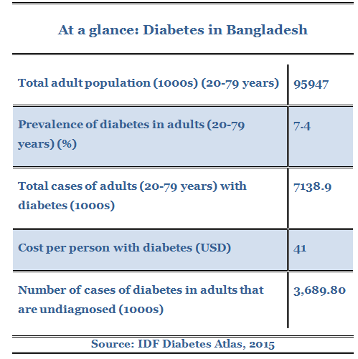

According to a report published in the WHO Bulletin in November 2013, there is a quite significant correlation between age and diabetes. Older people were more likely to have diabetes. A greater number of the affected population were educated and working and more likely to come from an affluent family with 40.7% came from the richest quintile, whereas 12.7% came from the poorest quintile.

The report also said that, urban people are slightly more prone to diabetes than the rural people and that 56.0% of affected people did not know they were carrying the disease and only 39.5% were receiving treatment regularly [2].

The main reasons why Bangladeshi people tend to have diabetes is:

* Genetic flaws like lean-Indian-complexity.
* Highly carbohydrate-dependent food pattern.
* Sedentary lifestyle & lack of physical labor.

From our surveys and interviews, we found out that diabetes patients tend to forget about the medicine timing, food taking timing which leaves them with serious consequences [2].

Our motivation was to make an android application to assist the people who have diabetes. So that, they were made aware about their food & medicine taking timing and maintain their Diabetes up to a certain level.

**ABSTRACT:**

Our goal is to help diabetes patients to remind them about their mealtime, medicine time and also insulin taking time. Our aim was to design a patient-friendly assistant application for the diabetes patient. It is basically an application that helps diabetes patient to remember their medicine because we know, diabetes patients sometimes forget their medicine, meal, sleeping and wake up timing. That is why we decided to make an application that will help diabetes patients to remind these things. We took face to face interview of 10 diabetes patients and collected some data for our project.

Our main goal is to help Diabetes patient to remember everything like an assistant to help them to eat, sleep and take their medicine/insulin timely. Also, trace their diabetes & record the updates for future references.

**Introduction:**

To start our project we needed a proper project plan to help us achieve our goal. At first, we studied the diabetes disease itself. The types, caused diseases, type of diagnosis, maintaining measures etc. Then we conducted a survey following by face to face interviews with people. Gaining important insights from our survey we designed our Android app features and finally put our effort to make a simple user-friendly mobile assistant application for the diabetes patients.

Our primary project was, using machine learning to predict the characteristic that a diabetic patient can have provided some features like - age, food & exercise habit, BMI etc. So for this purpose, we conducted a survey. The survey data was collected in 3 ways-

* Online survey
* Data from hospitals
* Manually collected survey from Dhanmondi Lake

Doing all these we could manage 151 data. Due to the scarcity of data we had to move to a different project. As we already conducted the survey on diabetes, we took interviews of 10 people so that we can have a better idea of what type of assistance a diabetic patient may need. With the pieces of information of our survey & interviews, we found out that most diabetic patients tend to forget their daily medicine, meal & exercise routines that may leave them in harmful health condition. That is why we decided to make a diabetic assistant android application. So that the diabetes patients can have a digital record of their daily activities and get a reminder for their medicines, meals & exercise.

**About The disease:**

Diabetes mellitus is a group of metabolic diseases characterized by high blood sugar (glucose) levels that result from defects in insulin secretion, or its action, or both. Diabetes mellitus, commonly referred to as diabetes was first identified as a disease associated with "sweet urine," and excessive muscle loss in the ancient world [1].

Normally, blood glucose levels are tightly controlled by insulin, a hormone produced by the pancreas. Insulin lowers the blood glucose level. When the blood glucose elevates (for example, after eating food), insulin is released from the pancreas to normalize the glucose level by promoting the uptake of glucose into body cells [5]. Diabetes is a chronic medical condition, meaning that although it can be controlled, it lasts a lifetime.

**There are two major types of diabetes:**

**1. Type 1 Diabetes**

**2. Type 2 Diabetes**

**Type 1 Diabetes:** Type 1 diabetes, the immune system mistakenly manufactures antibodies and inflammatory cells that are directed against and cause damage to patients' own body tissues. In persons with type 1 diabetes, the beta cells of the pancreas, which are responsible for insulin production, are attacked by the misdirected immune system [3].

Some of the antibodies seen in type 1 diabetes include anti-islet cell antibodies, anti-insulin antibodies and anti-glutamic decarboxylase antibodies. These antibodies can be detected in the majority of patients, and may help determine which individuals are at risk for developing type 1 diabetes [9].

Type 1 diabetes tends to occur in young, lean individuals, usually before 30 years of age; however, older patients do present with this form of diabetes on occasion. This subgroup is referred to as latent autoimmune diabetes in adults (LADA). LADA is a slow, progressive form of type 1 diabetes. Of all the people with diabetes, only approximately 10% have type 1 diabetes and the remaining 90% have type 2 diabetes [3].

**Type 2 Diabetes:** Type 2 diabetes was also previously referred to as non-insulin dependent diabetes mellitus (NIDDM), or adult-onset diabetes mellitus (AODM). In type 2 diabetes, patients can still produce insulin, but do so relatively inadequately for their body's needs, particularly in the face of insulin resistance as discussed above [6].

In addition to the problems with an increase in [insulin resistance](https://www.medicinenet.com/insulin_resistance/article.htm), the release of insulin by the pancreas may also be defective and suboptimal [4]. There is a known steady decline in beta cell production of insulin in type 2 diabetes that contributes to worsening glucose control. Finally, the [liver](https://www.medicinenet.com/liver_anatomy_and_function/article.htm) in these patients continues to produce glucose through a process called gluconeogenesis despite elevated glucose levels.

While it is said that type 2 diabetes occurs mostly in individuals over 30 years old and the incidence increases with age, an alarming number of patients with type 2 diabetes are barely in their teen years.

The prevalence of diabetes in persons 65 years of age and older is around 25%. Type 2 diabetes is also more common in certain ethnic groups. Compared with a 7% prevalence in non-Hispanic Caucasians, the prevalence in Asian Americans is estimated to be 8.0%, in Hispanics 13%, in blacks around 12.3%, and in certain Native American communities 20% to 50% [3].

**There are other type of diabetes also, they are:**

· Gestational diabetes

· Secondary diabetes

· Hormonal disturbances

· Medications

**Symptom of Diabetes:**

1. The early symptoms of untreated diabetes are related to elevated blood sugar levels, and loss of glucose in the urine. High amounts of glucose in the urine can cause increased urine output and lead to [dehydration](https://www.medicinenet.com/dehydration/article.htm).
2. The [dehydration](https://www.medicinenet.com/dehydration_pictures_slideshow/article.htm) also causes increased thirst and water consumption.
3. A relative or absolute insulin deficiency eventually leads to weight loss.
4. The [weight loss](https://www.medicinenet.com/lose_weight_without_dieting_pictures_slideshow/article.htm) of diabetes occurs despite an increase in appetite.
5. Some untreated diabetes patients also complain of fatigue.
6. [Nausea](https://www.medicinenet.com/nausea_and_vomiting/article.htm) and [vomiting](https://www.medicinenet.com/nausea_and_vomiting/article.htm) can also occur in patients with untreated diabetes.
7. Frequent infections (such as infections of the bladder, skin, and vaginal areas) are more likely to occur in people with untreated or poorly-controlled diabetes.
8. Fluctuations in blood glucose levels can lead to blurred vision.
9. Extremely elevated glucose levels can lead to lethargy and [coma](https://www.medicinenet.com/coma/article.htm).

**Risk of diabetes:**

Risk factors for type 2 diabetes and prediabetes are many. The following can raise your risk of developing type 2 diabetes:

* Being obese or overweight
* High blood pressure
* Elevated levels of triglycerides and low levels of "good" cholesterol (HDL)
* Sedentary lifestyle
* Family history
* Increasing age
* [Polycystic ovary syndrome](https://www.medicinenet.com/polycystic_ovary/article.htm)
* [Insulin resistance](https://www.medicinenet.com/insulin_resistance/article.htm)
* Gestational diabetes during a pregnancy [3]

**Methodology:**

Our application, Diabetes Assistant only consists of the software component. We worked on field and talked with the patients to do the survey. There is no hardware part required to give input to our application.

So, we first conducted a survey, followed by the interviews of people and then android application making.

**Survey Data analysis:**

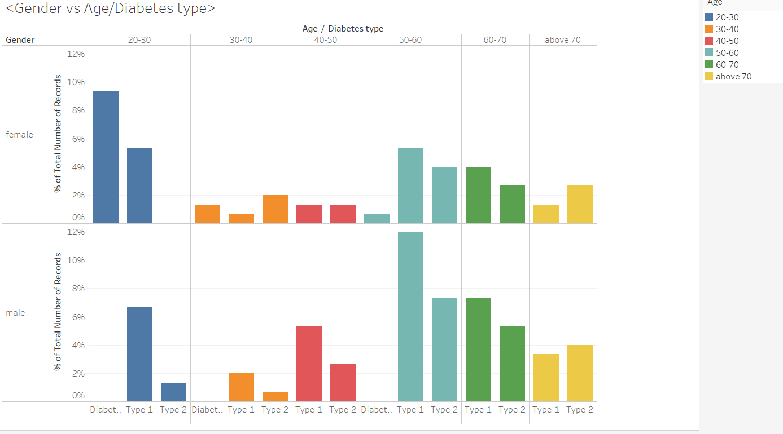

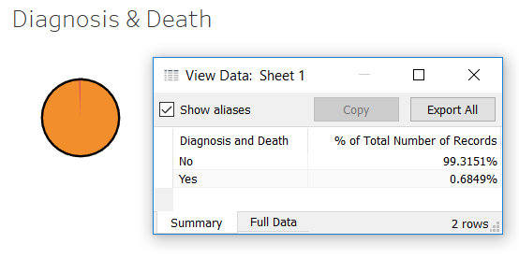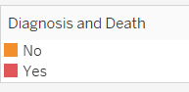

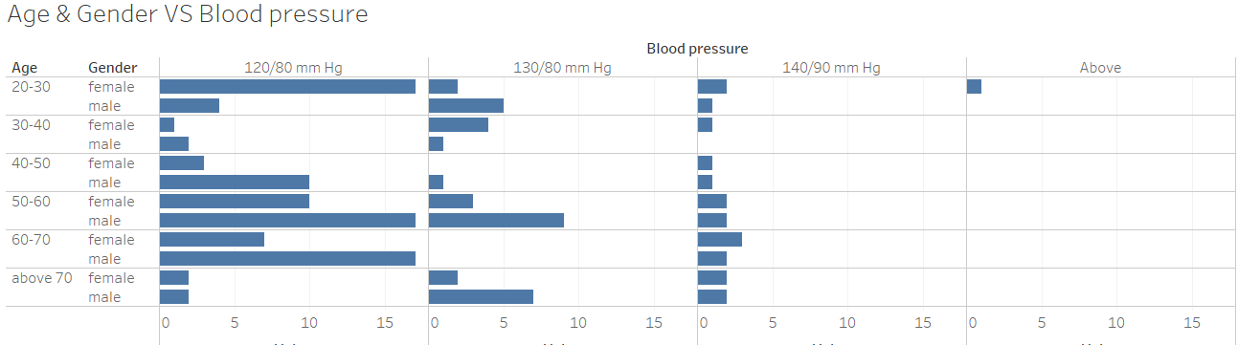

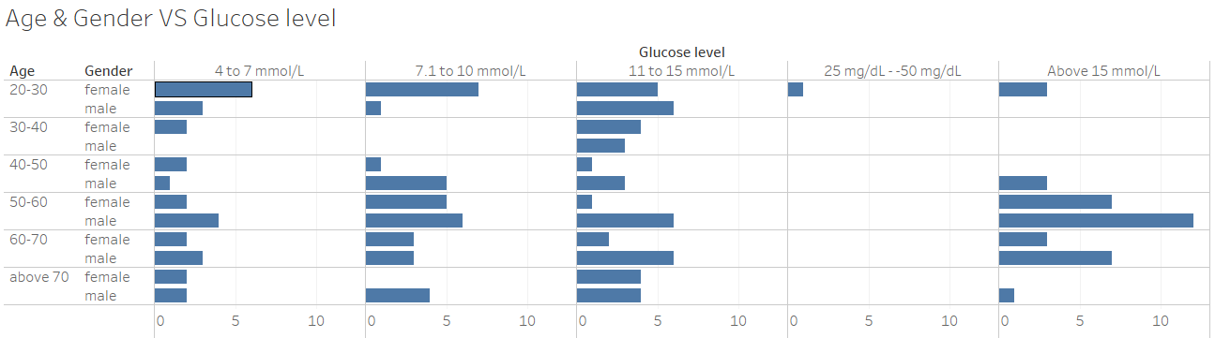

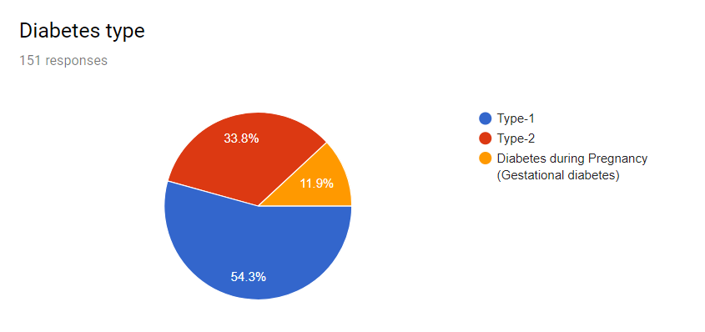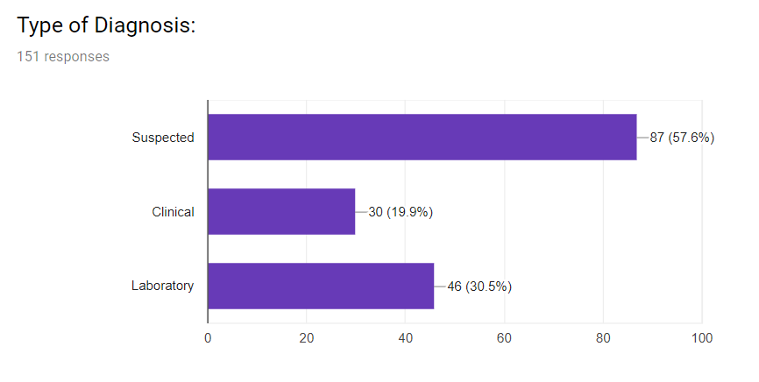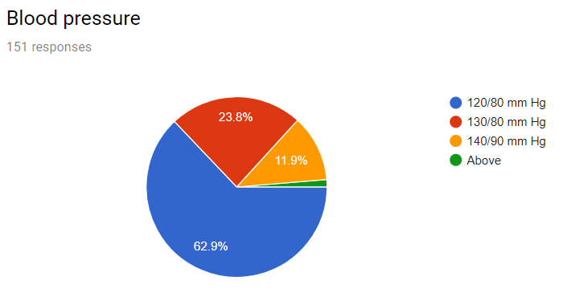

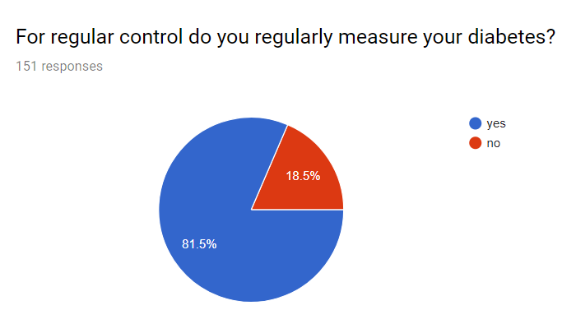

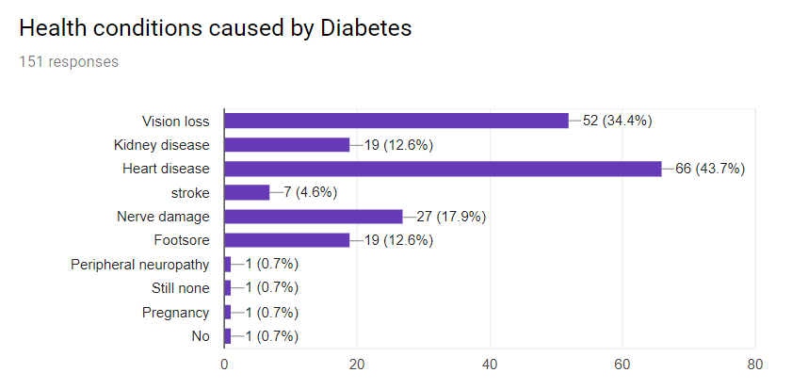

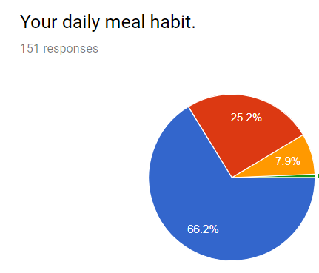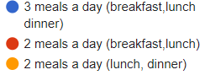

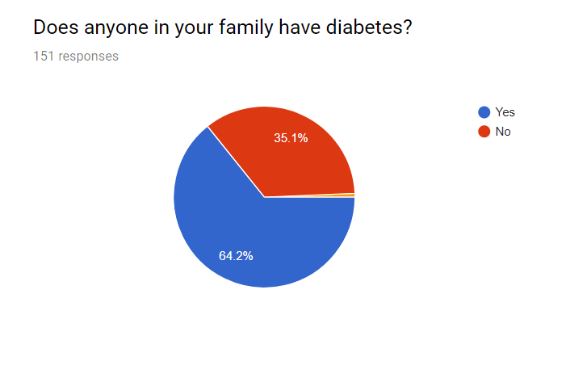

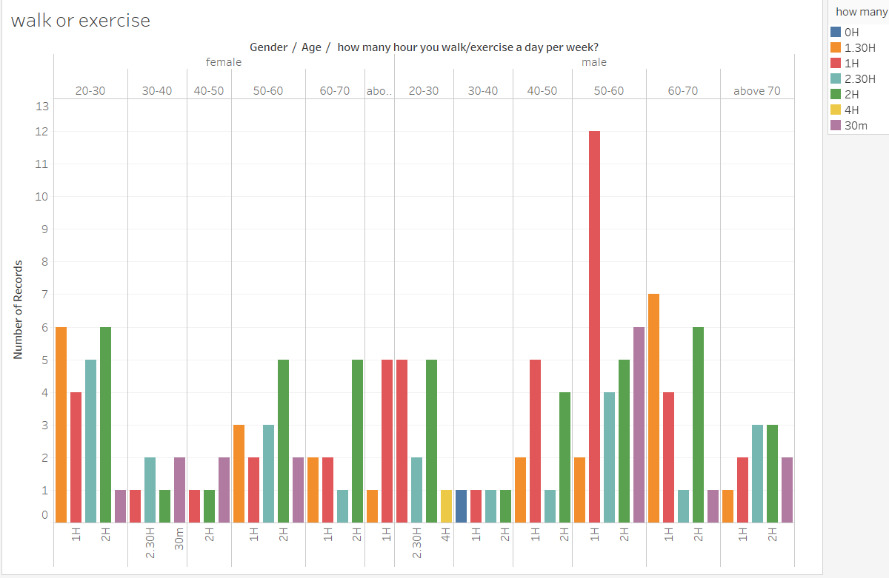

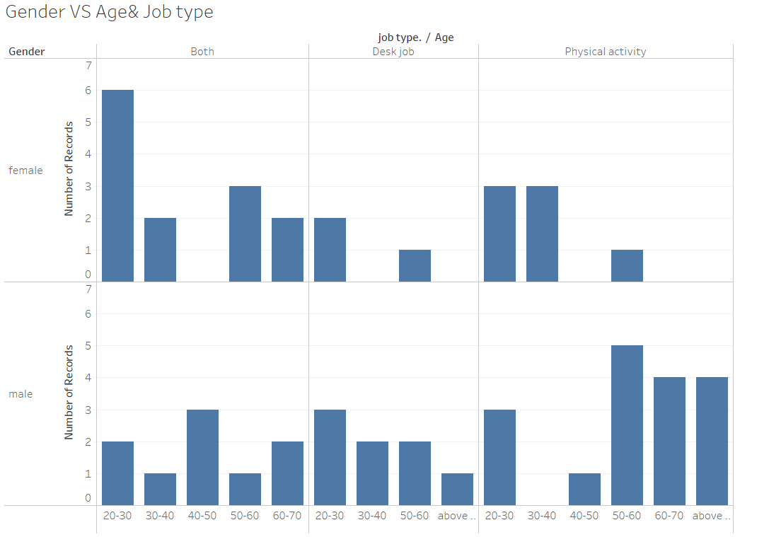

**Interview Questions & Answers:**

10 most important questions that we asked:

We interview more than 10 Diabetes Patient in face to face, we ask those Question to them and after getting answer we realized there problem to having diabetes and we tried to solve their problems as far as possible. Those question are -

1. When you eat your breakfast, lunch and dinner?

2. When you take your medicine/insulin per day?

3. What you most forget when you are in high diabetes?

4. What is your sugar/glucose level and when it high?

5. What do you do to control diabetes?

6. If high diabetes what should you choose? Take Medicine or Take Insulin?

7. What is you wake up and sleeping time and what is your daily meal time?

8. When you last check up your diabetes? How many days later you check your diabetes? Did you forget to check your diabetes after eating heavy food?

9. How do you know your diabetes is running low or running high?

10. What you forget most when you have high diabetes? In low diabetes what you forget to eat?

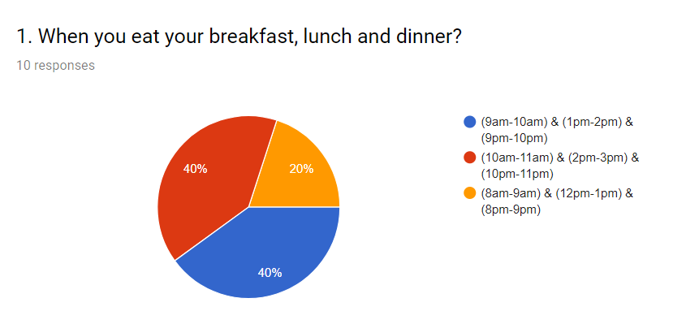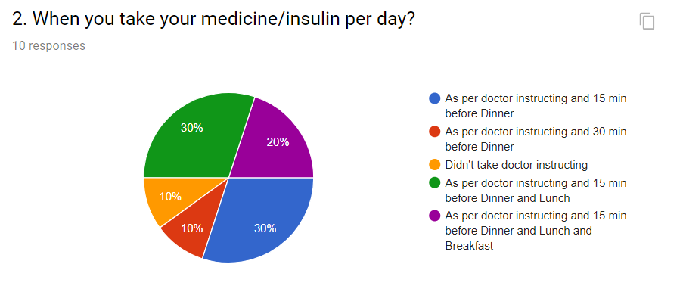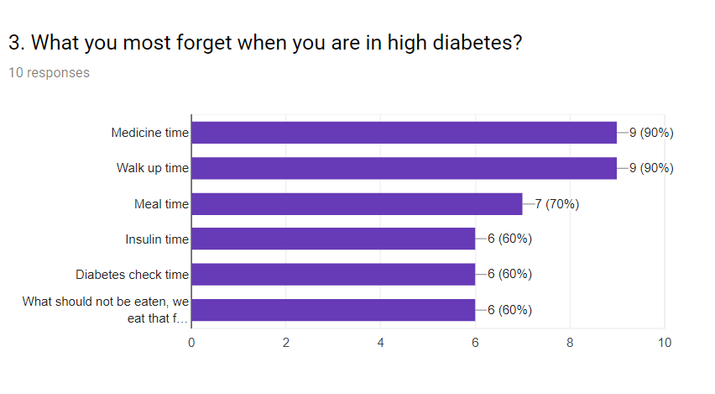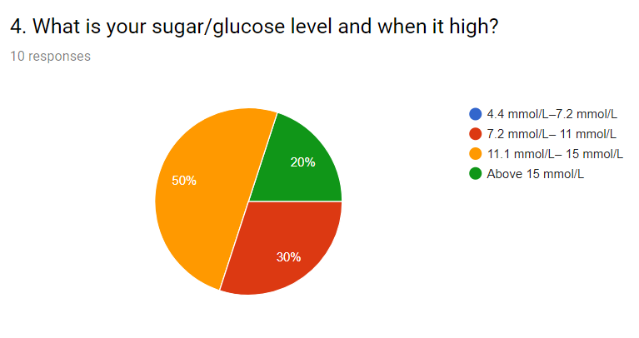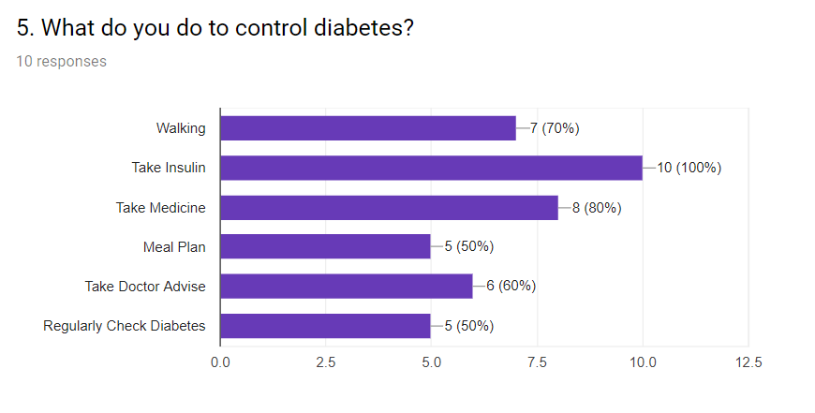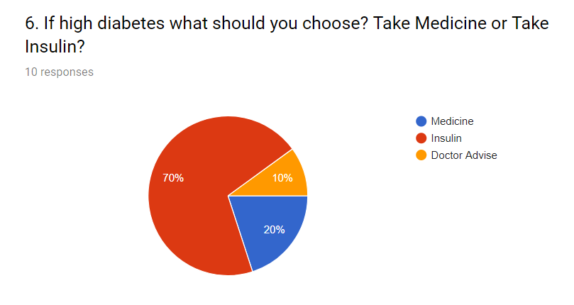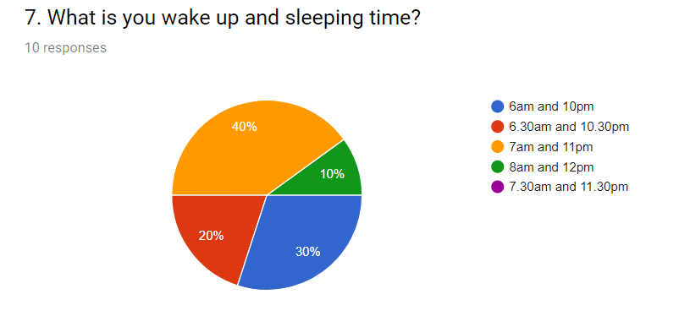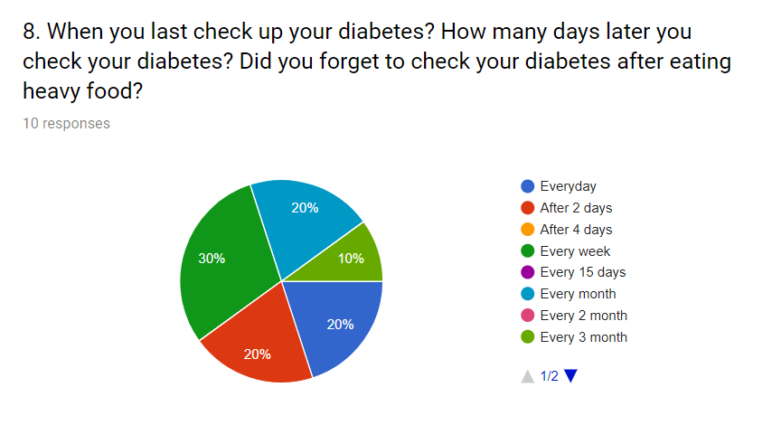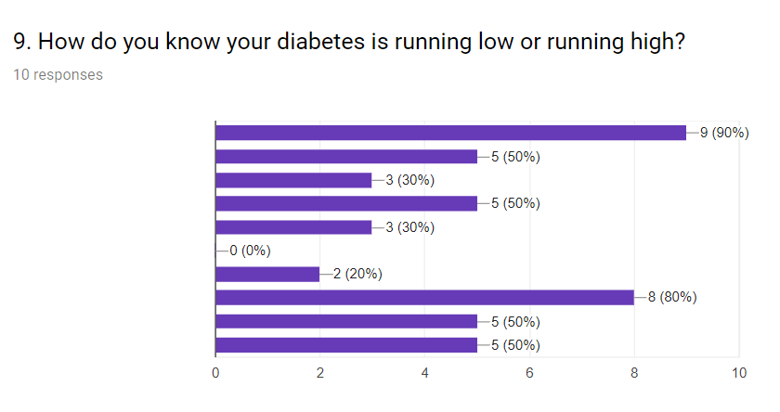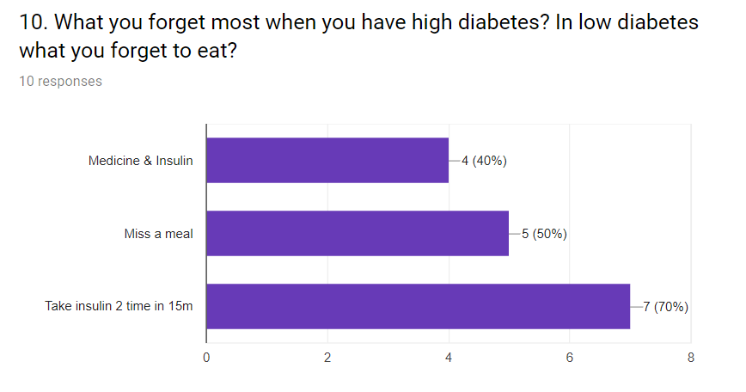

**The Application:**

We made our application keeping in mind that the most targeting patients using this application will be aged above 35+. We made this application as simple as possible. So that those who use this application, can use it comfortably and easily. We removed the registration and login system from our app because from our face to face interviews with patients, we found out that most people don't like the registration and login system as they find these annoying. By removing the registration and login system, we made our application simple and user-friendly for our target users.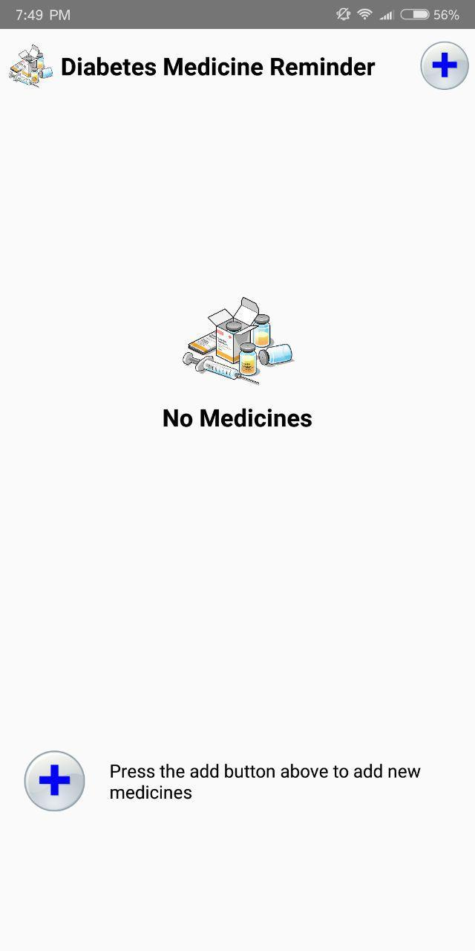

**HOME PAGE:**

With Button to add medicines.

**MEDICINE DETAILS AND ALARM ADD PAGE:** 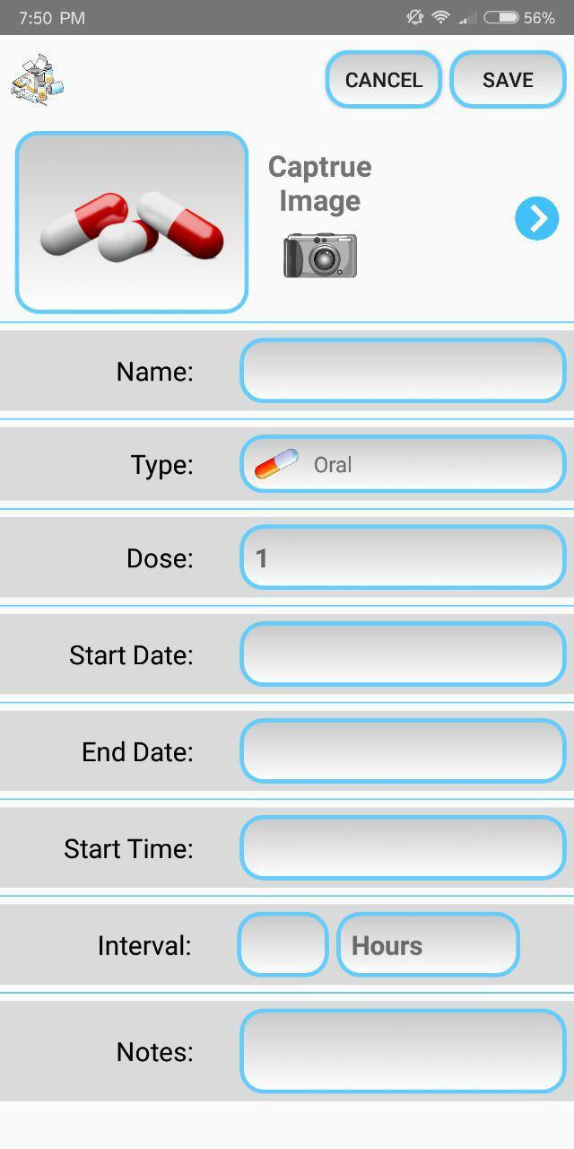

Patient can add

* Picture
* Name of Medicine
* What type of Medicine
* How many Dose you take at a time
* Start Date of your Medicine
* End Date of your Medicine
* Start Time or Alarm Time Daily
* Interval time by Hours
* Notes about your Medicine or Insulin

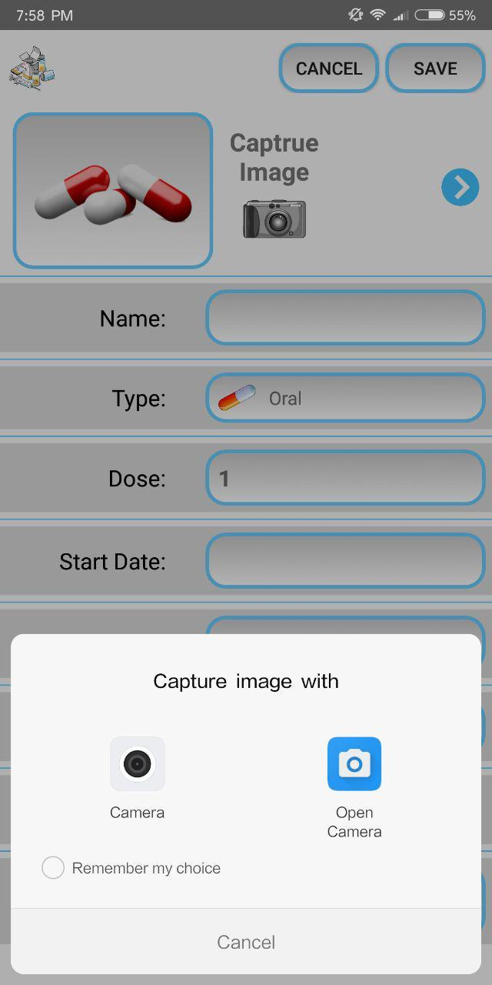

CAPTURE THE DIABETES MEDICINE OR INSULIN IMAGE

**DIFFERENT TYPE THAT PATIENT CAN CHOOSE:**

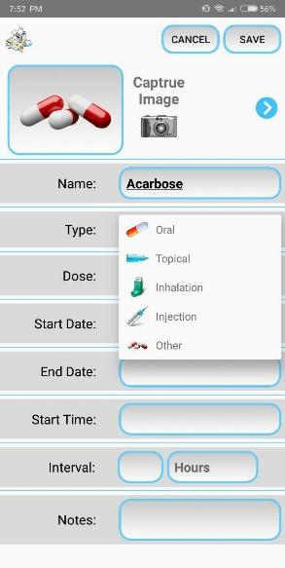

Oral

Topical

Insulin

Injection

Other

**DOSE THAT A PATIENT CAN CHOOSE:**

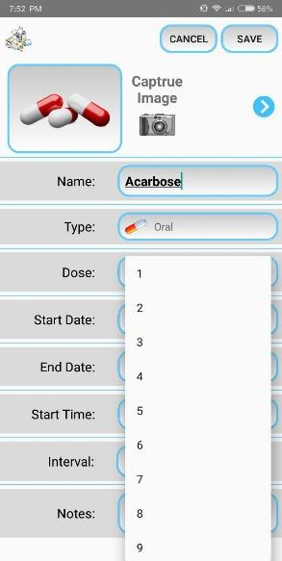

We added (1-10) For Dose

**START DATE AND END DATE:**

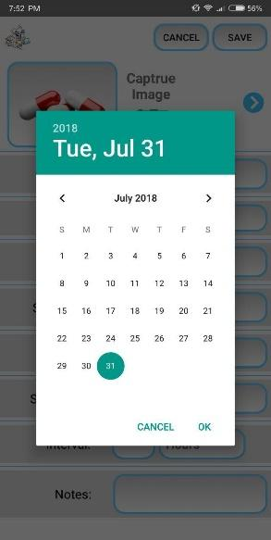

Date theme is normal android theme. It has a start date and an end date of a particular medicine/insulin course.

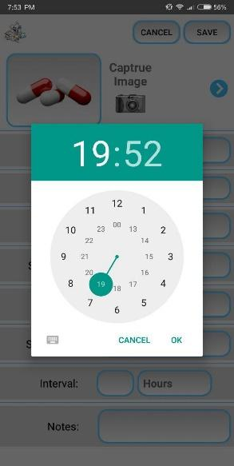**TIME FOR ALARM:**

We added the universal time which is simple to understand for a diabetes patient. It is a simple 24-hour clock that start at 12 and end at 24 so that the patients can understand easily.

**ALL THE MEDICINE AND INSULIN LIST :**

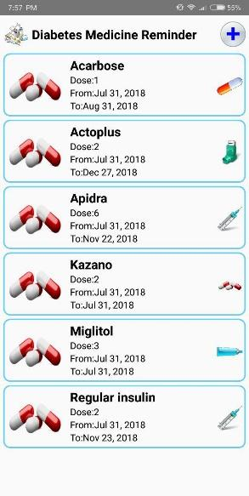

List of all the medicine with their start date of a dose and end date of a dose with their alarm time.

**EDIT PATIENT MEDICINE INFORMATION:**

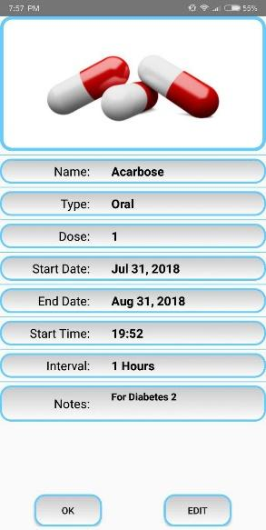

After adding all the information of medicine patient can edit those information also change their start and end date and also alarm time for a single medicine.

**DELETE MEDICINE**

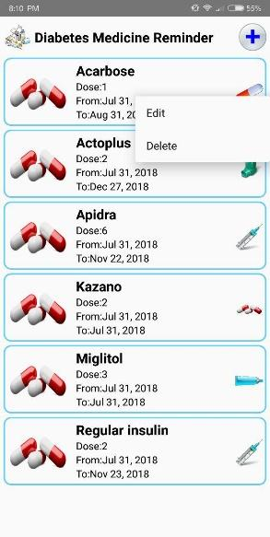

If any time doctor suggest for stop taking a specific medicine, patient can delete this medicine. Patient should just long click on that particular medicine that he/she want to delete and delete option will appear on the screen and he/she can delete this medicine.

**Discussion:**

We faced difficulties while collecting the data because there was a scarcity of data collection sources. We also had to do a lot of pre-processing of our data to prepare the data for graphical analysis.

**Future Development:**

We only added medicine reminder here. For future development, we can add food taking time, walking & exercise timing to give the patient time to time reminder and a better assistant.

**References:**

[1] Medical Author: Melissa Conrad Stöppler, MD, Medical Editor: William C. Shiel Jr., MD, FACP, FACR (2018) *Diabetes Symptoms, (Type 1 and Type 2),*And Available at: *https://www.medicinenet.com/diabetes_mellitus/article.htm #diabetes_type_1_and_type_2_definition_and_facts* (Accessed: 10th December 2017).

[4] Ibrahim Mahbub (27th July 2016) *The State of Diabetes In Bangladesh,*Retrieved from: <https://futurestartup.com/2016/07/27/the-state-of-diabetes-in-bangladesh/> .

[5] Ibrahim Mahbub (25th October, 2016) *Why Is Diabetes On The Rise In Bangladesh?*Retrieved from: <https://futurestartup.com/2016/10/25/why-is-diabetes-on-the-rise-in-bangladesh/>.

[7] Ibrahim Mahbub (25th June, 2017) *Diabetes Health Center,*Retrieved from: <https://www.webmd.com/diabetes/default.htm> .

[8] Diabetic Association of Bangladesh (12th January, 2018) *Diabetic Association of Bangladesh (BADAS),*Retrieved from: <http://www.dab-bd.org/> .

[9] Frose Jahan Chaity, Publisher: Dhaka Tribune (14th November, 2017) *15% pregnant women diagnosed with diabetes, Retrieved* from: <https://www.dhakatribune.com/health/2017/11/14/15-pregnant-women-diagnosed-diabetes/> .

***Journals***

[3] Lalo Magni, Ph.D.,1 Davide M. Raimondo, M.S.,1 Luca Bossi, M.S.,1 Chiara Dalla Man, Ph.D.,2 Giuseppe De Nicolao, Ph.D.,1 Boris Kovatchev, Ph.D.,3 and Claudio Cobelli, Ph.D.2 (November 1, 2007) 'Model Predictive Control of Type 1 Diabetes: An in Silico Trial', *Model Predictive Control of Type 1 Diabetes: An in Silico Trial,*Volume 1, Issue 6(Via Gradenigo 6/B, I-35131 Padova), pp. 805-806.

[2] Jacob A. Lykke, Jens Langhoff-Roos, Baha M. Sibai, Edmund F. Funai, Elizabeth W. Triche, Michael J. Paidas (1 May 2013) 'Hypertensive Pregnancy Disorders and Subsequent Cardiovascular Morbidity and Type 2 Diabetes Mellitus in the Mother', *Hypertension in Pregnancy and Subsequent Morbidity,*11 May 2009(Hypertension. 2009;53:944-951), pp. 11-14.

[6] Abhijit GURAV and Varsha JADHAV (24 July 2011 ) 'Periodontitis and risk of diabetes mellitus', *Periodontitis and risk of diabetes ,*5(10.1111/j.1753-0407.2010.00098.x), pp. 22-24.